**Yazi-RPC: 一个高性能的RPC框架**

**介绍**

**框架特性**

1. 操作系统：Linux
2. 编程语言：C++14
3. 完全独立：不依赖任何第三方库
4. 高性能：微秒级响应
5. 高并发：单机百万连接
6. IO多路复用：epoll
7. 连接池
8. 线程池
9. 用法简单

**服务端**

文件：server.cpp

|  |
| --- |
| C++ #include <iostream> using namespace std;  #include "Server.h" using namespace yazi::rpc;  string hello(const string & name) {  return "hello, " + name; }  int main() {  Server * server = Singleton<Server>::instance();  server->listen("127.0.0.1", 8080);  server->bind("hello", hello);  server->start();    return 0; } |

**客户端**

文件：client.cpp

|  |
| --- |
| C++ #include <iostream> using namespace std;  #include "Client.h" using namespace yazi::rpc;  int main() {  Client client;  client.connect("127.0.0.1", 8080);   auto reply = client.call<string>("hello", "kitty");  std::cout << reply << std::endl;    return 0; } |

**更多示例**

示例1：

|  |
| --- |
| C++ int sum(int a, int b) {  return a + b; } |

示例2：

|  |
| --- |
| C++ #include <string> #include <algorithm> using namespace std;  class Request : public Serializable { public:  Request() {}  Request(const string & name) : m_name(name) {}  ~Request() {}  const string & name() const  {  return m_name;  }  SERIALIZE(m_name) private:  string m_name; };  class Response : public Serializable { public:  Response() {}  Response(const string & name) : m_name(name) {}  ~Response() {}  const string & name() const  {  return m_name;  }  SERIALIZE(m_name) private:  string m_name; };  Response upper(const Request & req) {  string name = req.name();  transform(name.begin(), name.end(), name.begin(), ::toupper);  return Response(name); } |

**架构设计**

**整体架构**

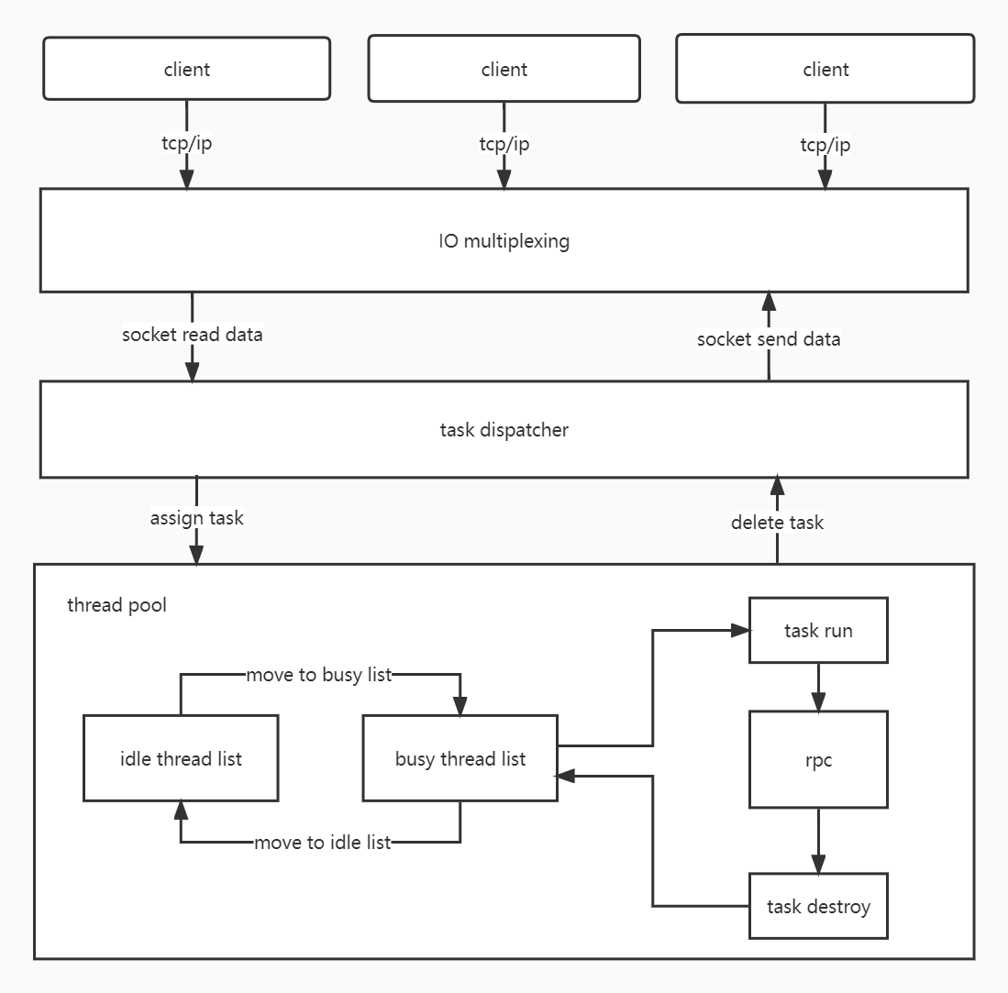

* IO多路复用模块：epoll
* 任务分发模块：task dispatcher
* 线程池：thread pool
* 任务执行模块：work task

**代码结构**

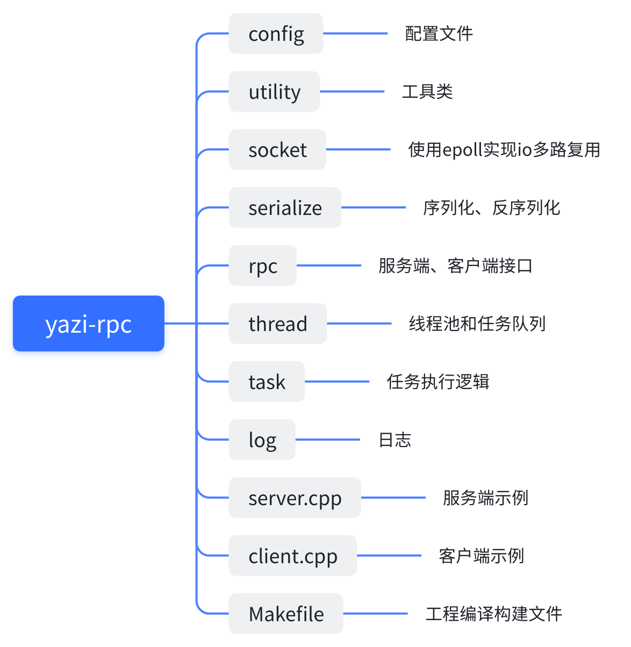

**关键问题**

1、高性能、高并发的网络框架

网络框架：yazi

https://www.bilibili.com/video/BV1hV4y1J7Ls/



2、客户端可变参数序列化

序列化组件：yazi-serialize

https://www.bilibili.com/video/BV1ad4y1x7VY/



3、服务端解包到不定参数列表

参考：buttonrpc

https://gitcode.net/mirrors/button-chen/buttonrpc_cpp14

需要用到c++14的特性

封装：rpc/FunctionHandler.h

关键代码：

|  |
| --- |
| C++ template<typename R, typename F, typename Tuple> typename std::enable_if<!std::is_same<R, void>::value, R>::type FunctionHandler::call_impl(F func, Tuple args) {  return invoke<R>(func, args); }  template<typename R, typename F, typename Tuple> auto FunctionHandler::invoke(F && func, Tuple && t) {  constexpr auto size = std::tuple_size<typename std::decay<Tuple>::type>::value;  return invoke_impl<R>(std::forward<F>(func), std::forward<Tuple>(t), std::make_index_sequence<size>{}); }  template<typename R, typename F, typename Tuple, std::size_t... Index> auto FunctionHandler::invoke_impl(F && func, Tuple && t, std::index_sequence<Index...>) {  return func(std::get<Index>(std::forward<Tuple>(t))...); }  template<typename Tuple, std::size_t... I> Tuple FunctionHandler::get_args(DataStream & ds, std::index_sequence<I...>) {  Tuple t;  initializer_list<int>{((get_arg<Tuple, I>(ds, t)), 0)...};  return t; }  template<typename Tuple, std::size_t Id> void FunctionHandler::get_arg(DataStream & ds, Tuple & t) {  ds >> std::get<Id>(t); } |

注意：gcc 5及以上版本才支持 c++14

**完结**